Chapter 17, Solution 40.

The signal in Fig. 17.76(a) is applied to the circuit in Fig. 17.76(b). Find v_{o}(t).

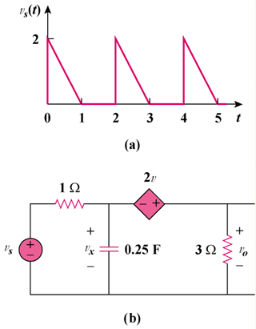

2v_{x}

Figure 17.76
For Prob. 17.40.

Solution

T = 2, ω_{o} = 2π/T = π
a_{o} =
a_{n} =
=
=
b_{n} =
=
v_{s}(t) =
where

For the DC component, v_{s} = 1/2. As shown in Figure (a), the capacitor acts like an open circuit.

+

V_{x}

−

i

1 Ω

3 Ω

0.5V

+
−
− +

V_{x}

(a)

+

V_{o}

−

2V_{x}

V_{o}

1 Ω

3 Ω

V_{S}

+
−
− +

V_{x}

(b)

+

V_{o}

−

2V_{x}

(1/4)F

V_{o}

Applying KVL to the circuit in Figure (a) gives

–0.5 – 2V_{x} + 4i = 0 (1)

But –0.5 + i + V_{x} = 0 or –1 + 2V_{x} + 2i = 0 (2)

Adding (1) and (2), –1.5 + 6i = 0 or i = 0.25

V_{o} = 3i = 0.75

For the nth harmonic, we consider the circuit in Figure (b).

ω_{n} = nπ, V_{s} = A_{n}∠–φ, 1/(jω_{n}C) = –j4/(nπ)

At the supernode,
(V_{s} – V_{x})/1 = –[nπ/(j4)]V_{x} + V_{o}/3

V_{s} = [1 + jnπ/4]V_{x} + V_{o}/3 (3)

But –V_{x} – 2V_{x} + V_{o} = 0 or V_{o} = 3V_{x}

Substituting this into (3),

V_{s} = [1 + jnπ/4]V_{x} + V_{x} = [2 + jnπ/4]V_{x}

= (1/3)[2 + jnπ/4]V_{o} = (1/12)[8 + jnπ]V_{o}

V_{o} = 12V_{s}/(8 + jnπ) =

V_{o} =

Thus
v_{o}(t) = volts
where
V_{n} = and

θ_{n} = tan^{–1}(nπ/8) – tan^{–1}(π(2n – 1)/(2n))

